Chapter 11, Solution 40.

Design a problem to help other students to better understand apparent power and power factor.

Although there are many ways to work this problem, this is an example based on the same kind of problem asked in the third edition.

Problem

A load consisting of induction motors is drawing 80 kW from a 220-V, 60 Hz power line at a pf of 0.72 lagging. Find the capacitance of a capacitor required to raise the pf to 0.92.

Solution

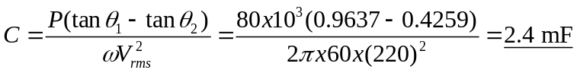,

{Again, we need to note that this capacitor will be exposed to a peak voltage of 311.08V and must be rated to at least this level, preferably higher!}

